**The Qwuloolt Estuary Ecosystem Restoration project**

**Project Overview**

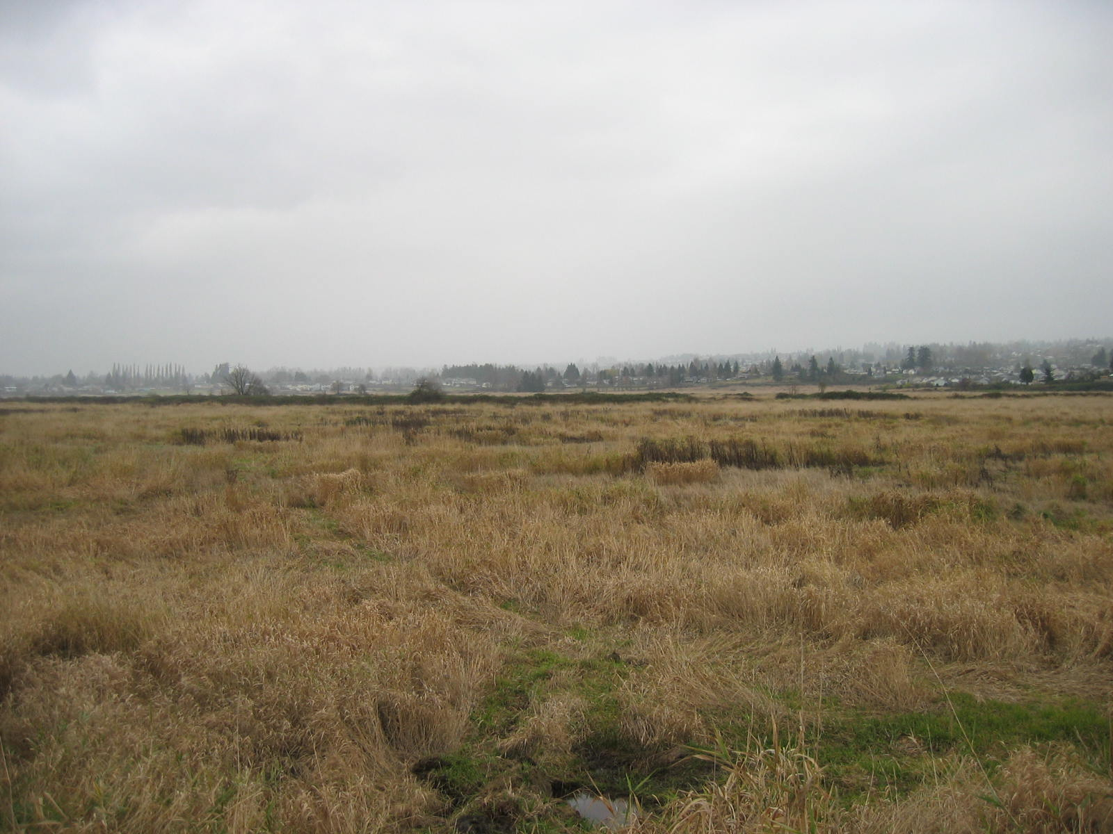  
The Qwuloolt Estuary Ecosystem Restoration project is part of the Puget Sound and Adjacent Waters Restoration Program authorized under Section 544 of the Water Resource Development Act of 2000. The program focuses on implementing critical projects for the preservation, protection and restoration of critical ecosystem processes, habitats, and functions within the Puget Sound basin. Priority projects are selected by consulting with regional stakeholders including non-profit organizations, tribes, the state and federal agencies.

The Qwuloolt Estuary Restoration Project is a major project to restore critical estuary habitat along the Snohomish River led by the U.S. Army Corps of Engineers and Tulalip Tribes of Washington. When complete it will restore tidal access to about 360 acres of historic floodplain. The Tulalip Tribes partnered with several city, state and federal agencies on other projects in the area designed to restore historic and critical tidal wetlands in the Snohomish River estuary.

The Corps and Tulalip Tribes signed a partnership agreement in 2012. The Corps awarded a $3.73 million, two-phase construction contract to Sealaska, of Auburn, Wash., and construction began in August 2013. Work will take about two years to complete.

In phase one, workers will construct a 4,000-foot setback levee to protect Brashler Industrial Park, the Marysville Wastewater Treatment Plant and residents surrounding the area. Phase two involves lowering 1,400 feet of the Ebey Slough dike and then excavating a 270-foot breach in it to allow tidal inundation.

Qwuloolt is part of a 16-square-mile Snohomish River estuary that historically included marshes, lowland forest, mudflats and interconnected channels which the Tulalip Tribes ancestors traversed by canoes. It offered a wide variety of plant and animal life that helped sustain villages surrounding the estuary. In the early part of the 20th century a dike was constructed on the current project site and tide gates were installed, preventing tidal access, and destroying the estuary’s marsh habitats. As a result, salmon and other estuarine-dependent species were unable to use the highly-productive environment.

Restoring tidal processes to what became fallow pasturelands will improve local streams and wetland for fish such as endangered Chinook salmon, bull trout and steelhead.